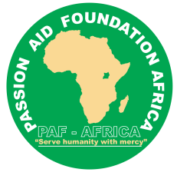 **PASSION AID FOUNDATION AFRICA**

P.O BOX 330480 LIRA CITY, NORTHERN UGANDA

Email: [africapaf@gmail.com](mailto:africapaf@gmail.com)

**Tel: +256 789 104 159 / +256 789 280 711**

**Who we are:**

Passion Aid Foundation Africa is a Non-Governmental Organization dedicated to working with vulnerable children, elderly persons, families, persons with disability and people living with HIV/AIDS and their communities to reach their full potential by tackling the causes of poverty, fundamental Human rights issues, and injustices in community. PAF-Africa provides emergency assistance to children and families affected by natural disasters and civil conflict, works with communities to develop long-term solutions to alleviate poverty, and advocates for justice on behalf of the poor, partner with development partners both in the country and beyond in promoting the culture of peace, child sponsorship to enable vulnerable children enter and remain in school system among others.

**WHERE WE WORK:**

We are visible in the Sub-Regions of Acholi, Lango, Teso, West Nile-in emergency response and Karamoja with its head office in Lira City, Northern Uganda. To help secure a better future for each child, we focus on lasting, community-based transformation. We partner with individuals and communities, empowering them to develop sustainable access to clean water, food supplies, healthcare, education, and economic opportunities.

**Our Address:**

Kichope Cell, Ojwina C Ward, Lira City West Division

P.O Box 330488, Lira City, Northern Uganda

Email: [africapaf@gmail.com](mailto:africapaf@gmail.com)

Tel: +256 789 104 159 **/** +256 789 280 711

**Map of Uganda showing where we work:**

**Our thematic Areas: ( please create tabs for each thematic areas bellow)**

* Maternal, neonatal and child health & Quality Reproductive health for young people.
* Keeping children safe from all forms of abuse.
* Skilling the Youth.
* Livelihoods:
* Disaster and emergency Response.
* Early childhood care and primary education.
* Human rights and good governance.
* Climate change, Environmental Protection and Adaptation.

Our Country strategy:

Passion Aid Foundation Africa strives to advance human rights and equality for women, youth, children all over Uganda, promotes climate change adaptation, Health, Education, livelihoods, Disaster and Emergency response and skilling the Youth in creating employment opportunities.

Passion Aid Foundation Africa is an independent non-governmental organization, we work alongside children, young people, women, community structures, partners, existing government structures that support our engagements in addressing the challenges facing children, youth, women, elderly, and communities in tackling the root causes of injustices, exploitation, violations, and abuse.

We support children through child sponsorship, mentorship and coaching for the youth, build farmers knowledge and skills in value chain & addition, climate change adaptation mechanisms, collaborate and coordinate on provision of integrated health services, youth skilling targeted unemployed youth, single mothers, building resilience on disaster management, peace building & conflict resolution, creating enabling environment for early childhood education.

HOW:

We will work through partners, Academic institutions, Government structures, private individuals and proprietors, community based, and youth led organizations, as a champion in development, we advocate for policy reforms, equity and equality in programmes that work for everyone, while building more effective civil society-government relations.

**Our Country strategy:**

|  |  |
| --- | --- |
| WHAT WE WILL DO | |
| OUR COUNTRY PROGRAM | |
| GOAL FOR 2023 TO 2027:  *Children and youth especially girls develop their full potential in communities that promotes their rights, gender equality and contribute to climate change adaptation.* | |
| Maternal, neonatal and child health & Quality Reproductive health for young people. | **Disaster and emergency Response.** |
| Coordinate, collaborate and promote on the provision of integrated Health Services and best parenting child care practices. | Emergency relief to disadvantaged communities and empowering them in building resilience and copying mechanisms in mitigating further disasters. |
| Keeping children safe from all forms of abuse. | **Early childhood care and primary education.** |
| Promotes the protection of children from Early Forced Marriages, unplanned, undesired, or forced pregnancy, sexual violence and Gender based Violence services, while enabling access and use of Adolescent Sexual and Reproductive Health services. | Creating enabling environment for quality learning and experience sharing for children from early childhood to working age while nurturing them to respond to Life challenges. |
| Skilling the Youth. | **Human rights and good governance.** |
| Provision of strategic integrated skills in various trades ad creating employment opportunities for the youth. | Promoting transparency, accountability, service delivery, peace and conflict resolution. |
| Livelihoods: | **Climate change, Environmental Protection and Adaptation.** |
| Promoting better farming practices, value chain and addition. | Promoting adaptation strategies in responding to changing climate and promoting environmental protection mechanisms. |
| Core Methodologies | |
| Positive parenting/ Parenting Under Pressure Savings groups for youth and parents, Health systems strengthening, advocacy and influencing, community engagements, farmer field schools, farmers groups, child protection committees and  Comprehensive Sexuality Education | Champions of Change & Peer Education, Community and Couple Dialogue, Young Citizen Scorecards Engaging religious and cultural institutions  Community Led Action for Children (CLAC), Learning through play, Participatory school governance, Climate Change Education, child sponsorship, community bar razors and emergency response in preparation, mitigation, rescue & relief and Rehabilitation. |
| Influencing Agenda | |
| Better climate change adaptation strategies, resilience, and environmental protection, duty bearers held responsible & accountable, disaster risk mitigation strategies improved, early childcare, safer and more gender responsive schools, social protection for poor children and youth and their families. Informed choices about their sexual and reproductive health, support them to access quality sexual reproductive health services and information and to be protected from early pregnancy and sexual gender-based violence. | |

**Impact of sponsorship on the life of a child.**

Child sponsorship gives hope to the vulnerable children; it provides education and health-related support for an individual child. Sponsored children have access to counselling and guidance.

* **What to expect.**
* An opportunity to exchange letters with the child.
* Opportunity to exchange gifts with the child.
* An annual progress report on the child’s development.
* An opportunity to visit the child and the family.

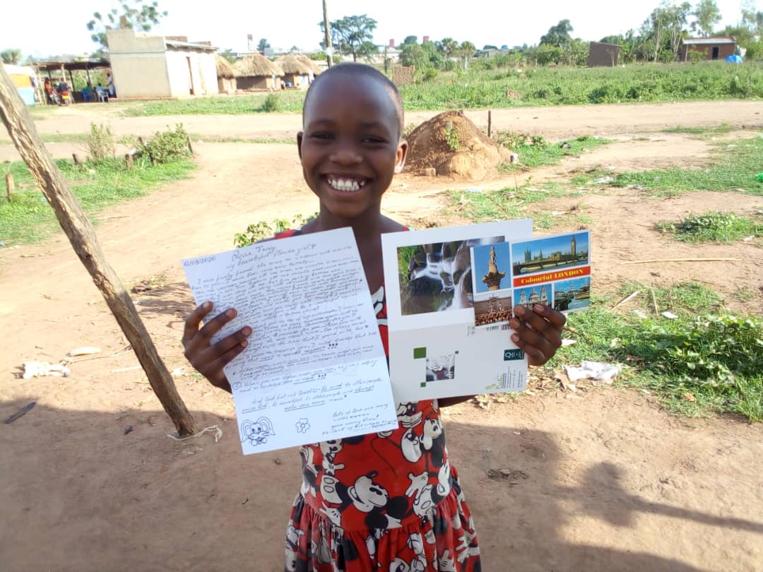

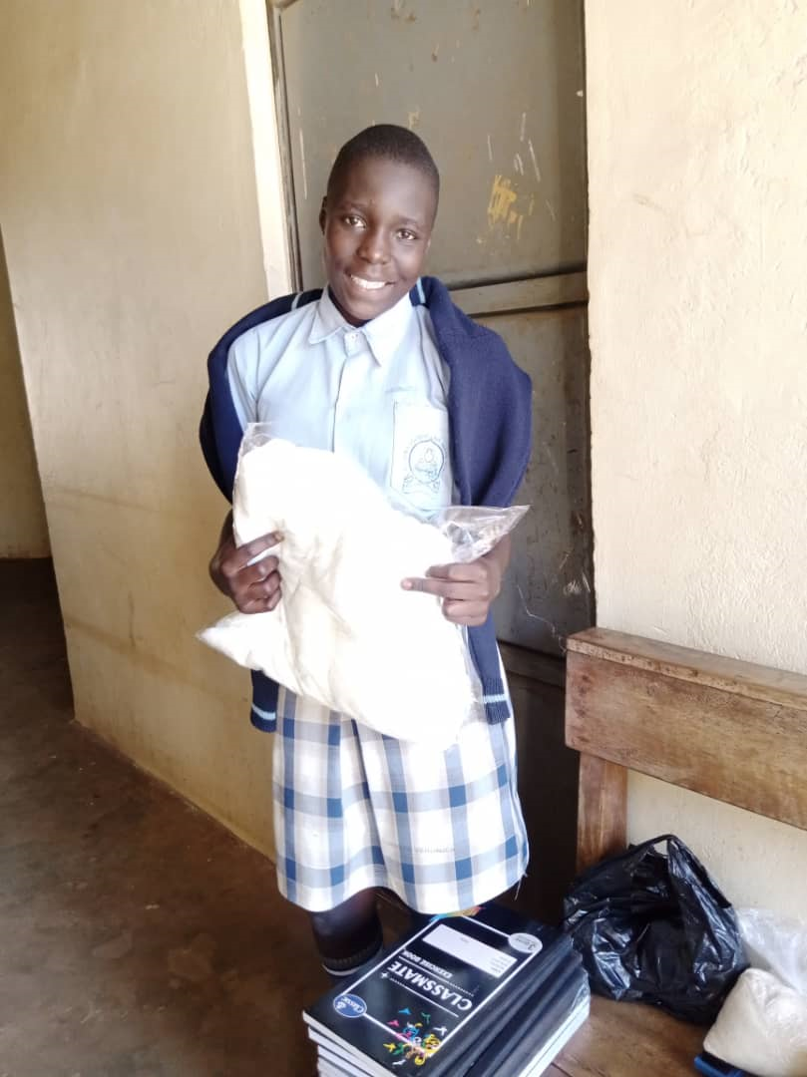

Create tab for Partnership:

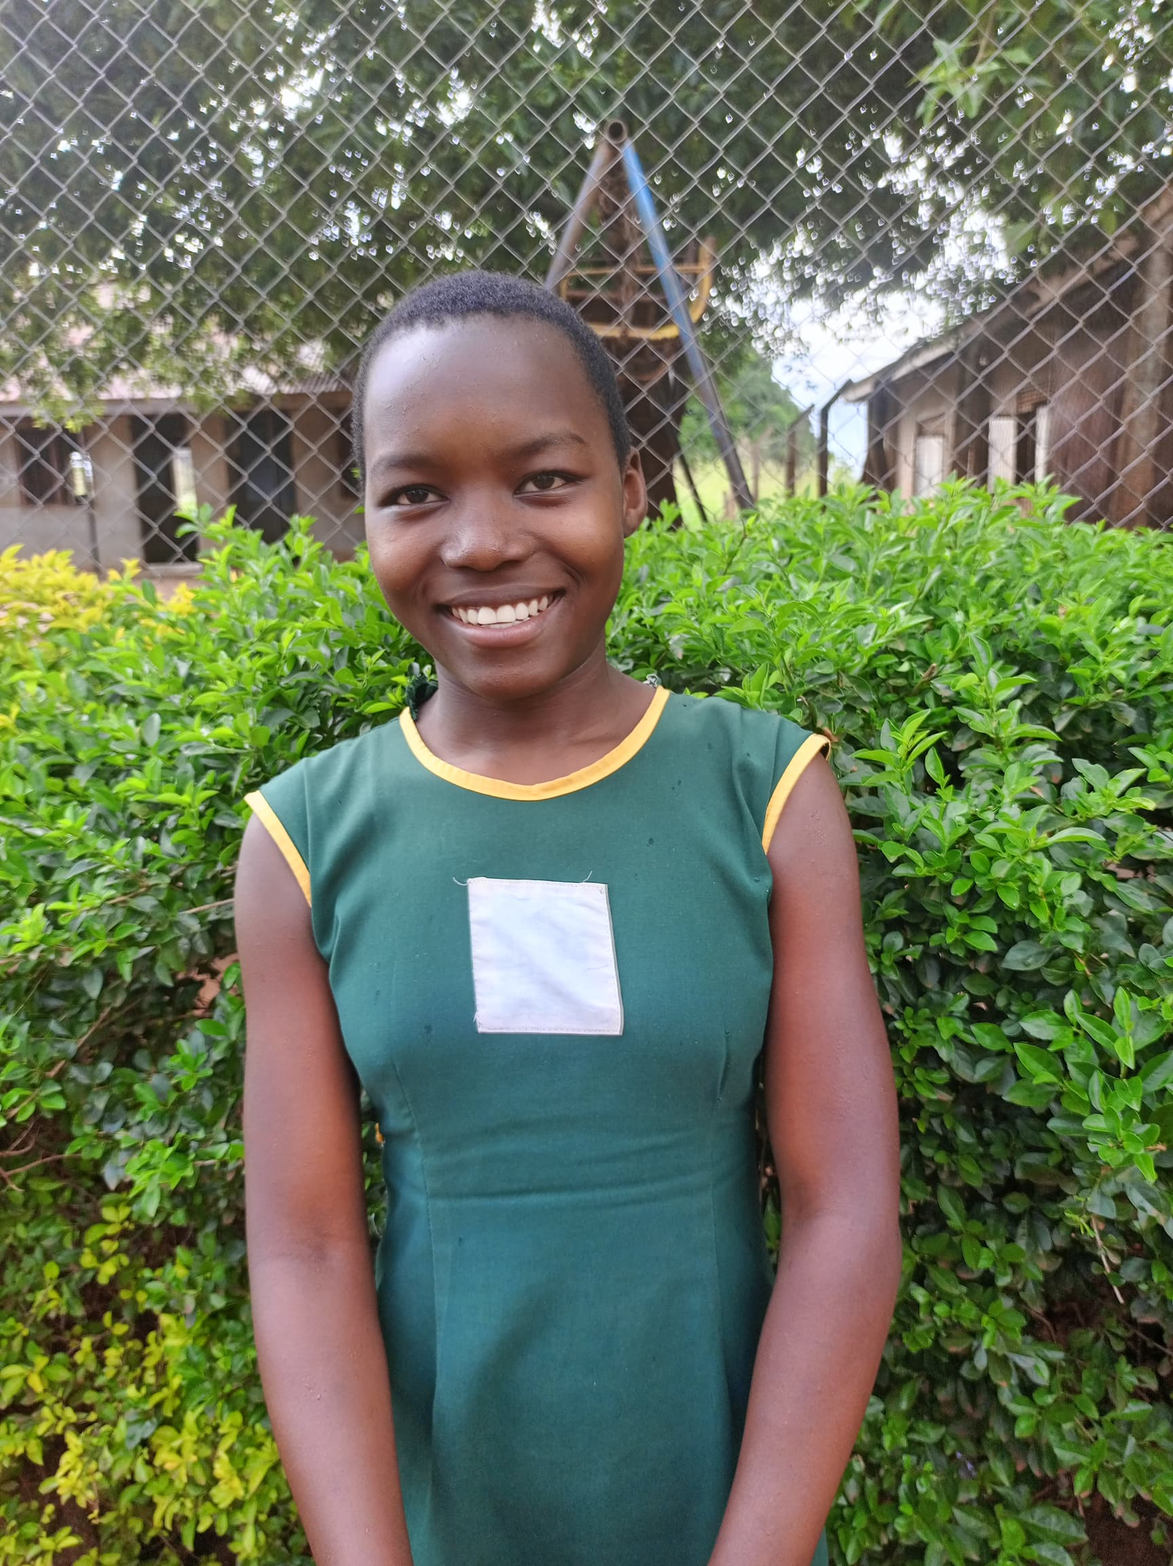

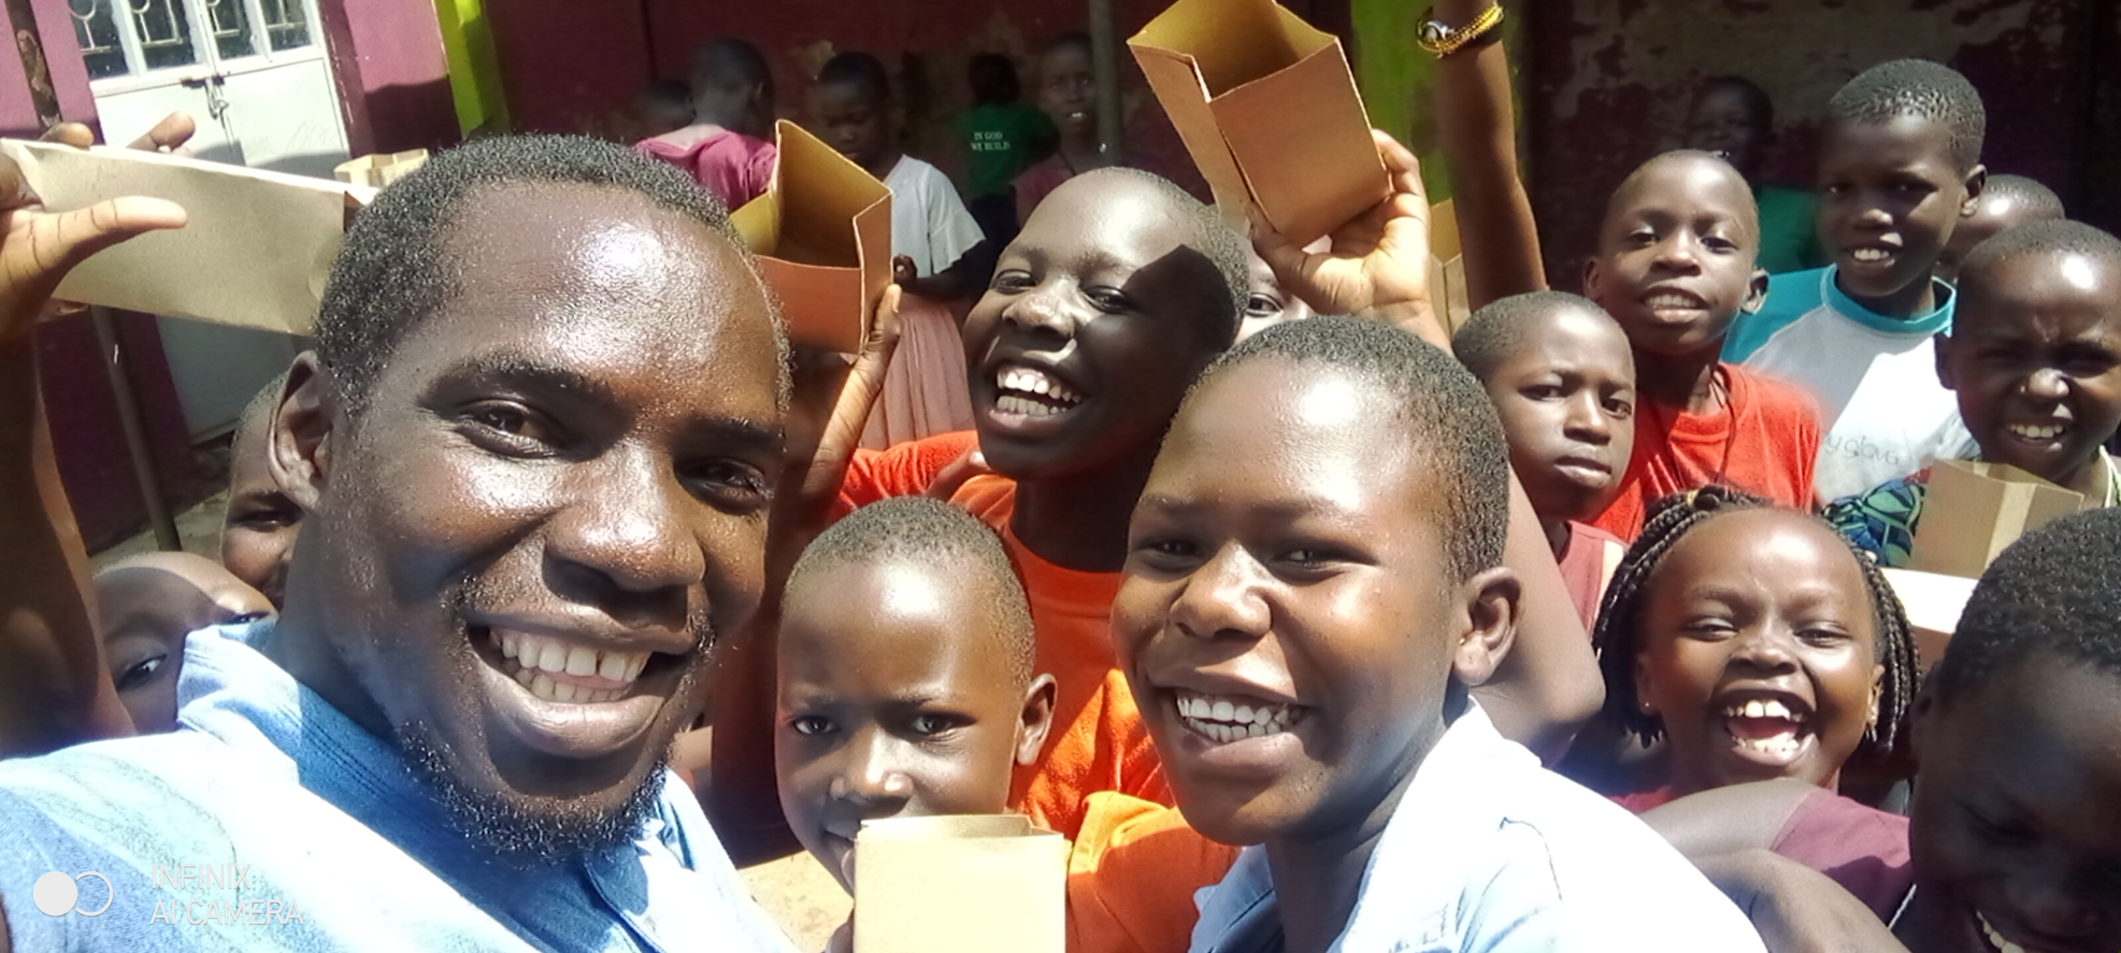

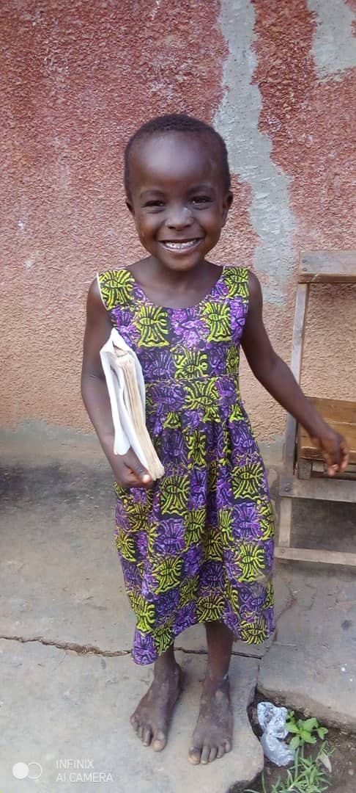

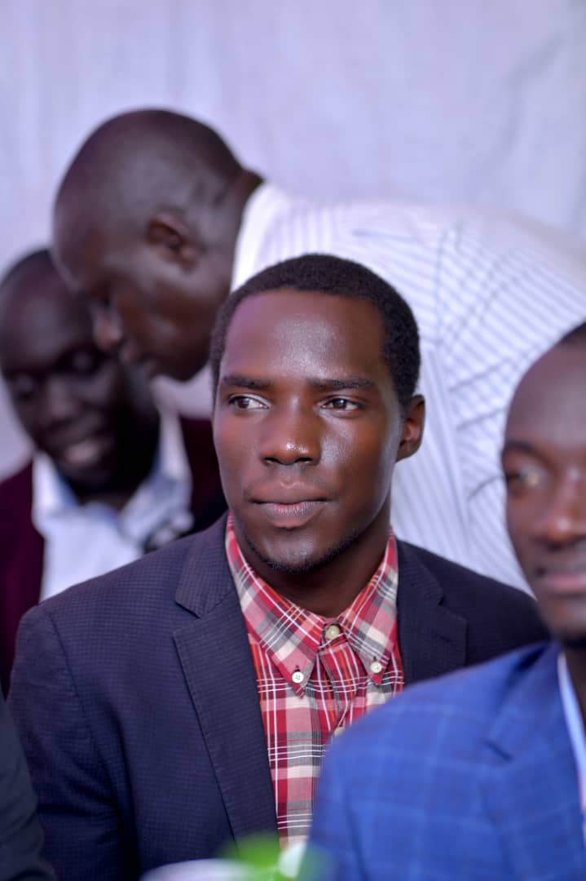 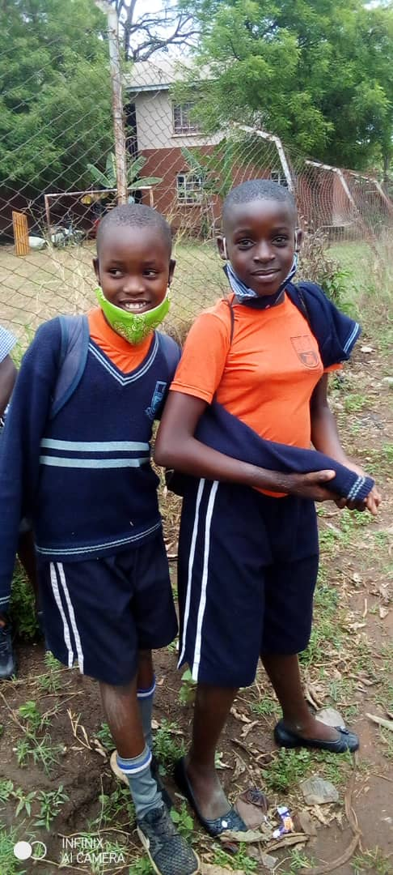  
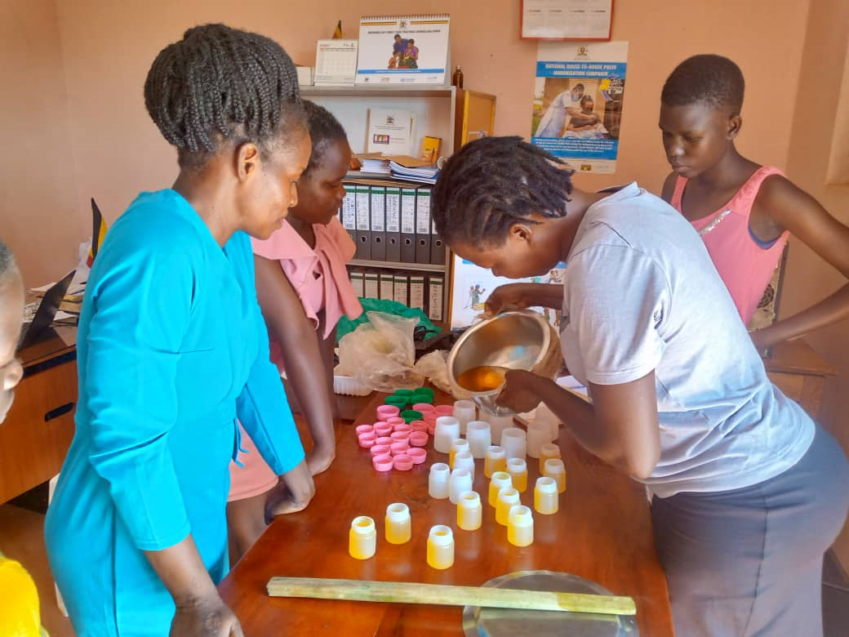

Founder & Executive Director: Daniel Okello

